

**George Mason University**

12/10/2022

**Fall**

**2022**

Pratibha Pandey

Lorenzo Rollhauser

Delaney Taubenberger

Jonathan Tyler

Robert V Mikula

**DAEN 690**

**Project Report**

**IMAGE PROCESSING SATELLITE IMAGES FOR CONTRAILS**



Abstract 4

1 Introduction 5

1.1 Background 5

1.2 Problem Space 7

1.3 Research 8

1.4 Solution Space 9

1.5 Project Objectives 9

1.6 Primary User Stories 9

1.7 Product Vision 10

1.8 Definition of Terms 10

2 Data Acquisition 12

2.1 Overview 12

2.2 Field Descriptions 12

2.3 Data Context 12

2.4 Data Conditioning 13

2.5 Data Quality Assessment 14

2.6 Other Data Sources 15

3 Analytics and Algorithms 16

3.1 Hopper 16

3.1.1 Neural Network Structure 17

3.1.2 ResNet50 18

3.2 SageMaker 19

4 Visualization 24

5 Findings 36

6 Summary 37

7 Future Work 38

8 Appendix A: Code References 39

8.1 Team Error-Plane 39

8.2 Developers 39

9 Appendix B: Risk Section 39

9.1 Sprint 1 Risks 39

9.2 Sprint 2 Risks 40

9.3 Sprint 3 Risks 40

9.4 Sprint 4 Risks 41

9.5 Sprint 5 Risks 41

10 Appendix C: Agile Development 42

10.1 Scrum Methodology 42

10.2 Sprint 1 Analysis 42

10.3 Sprint 2 Analysis 43

10.4 Sprint 3 Analysis 43

10.5 Sprint 4 Analysis 43

10.6 Sprint 5 Analysis 44

11 References 45

# Abstract

Pollution caused by the amount of air traffic by commercial airlines has proved to have hazardous consequences on the environment. This is a byproduct of the exhaust released by aircraft into the atmosphere. The build-up of exhaust over time from aircraft combined with cold temperatures form condensation trails known as contrails. Contrails present a worrisome problem to global warming since these cirrus-like clouds ultimately reflect radiation that is meant to exit earth back onto it, thus trapping heat on our planet. The challenge to eliminating contrails lies in being able to accurately differentiate them from naturally formed cirrus clouds. One approach to identifying these manmade clouds is through satellite imagery. By collecting Landsat Satellite images, annotating them, and training a machine learning model previous research was able to accurately detect contrails at a 7.3% precision. The previous team established a solid foundation for which we have been able to build through a similar but different approach. Our process similarly included the annotation and splitting of Landsat images previously identified by Google into training, testing, and validation. The difference came in the models we implemented to identify contrails. The model chosen utilizes binary classification to differentiate images into groups identified as having the presence of contrails or no contrails. The performance of the model was tested on four different binary classifier families and tried on different bands to root out the combination that results in optimal accuracy. The most accurate model tested was the resnet model. This model has an accuracy of 77%. Through continued efforts to improve upon the accuracy of the binary classification algorithms in place, the aim is to one day have air traffic control confidently implement the contrail detection models to deter airplanes from frequenting airspace polluted by contrails.

# Introduction

## Background

Have you ever looked up into a perfect blue cloudless sky and seen streaks of thin white clouds? If you have that means you have most likely seen a contrail. A condensation trail, or contrail, is an aircraft-induced cirrus cloud that appears if the temperature where the aircraft is flying is significantly cold enough and has the correct amount of humidity [1].

According to the Schmidt-Appleman criterion, contrails are likely to form due to the increase in heat and water vapor that occurs in an engine plume when it mixes with the colder air that surrounds the aircraft [1]. The water vapor released by the aircraft is not only water but contains soot and volatile particles. The volatile particles can conatal “carbon dioxide, and small amounts of nitrogen oxides, hydrocarbons, carbon monoxide, sulphuric oxides (oxidation products of sulfur-containing molecules included in aviation fuels), some organic material (partially condensable), and chemi-ions (charged molecular clusters formed during combustion in the engine), soot (organic and black carbon) and possibly small metal particles (from mechanical erosion)” [1]. These particles do not play a large role in the actual formation of contrails.

Contrails usually appear in specific condition thresholds. These conditions depend on relative humidity and the ratio between water vapor pressure and temperature at the time of mixing [1]. Figure 1 shows the threshold temperatures based on relative humidity (RH) at different altitudes. The figure shows that at temperatures below the line for 0% relative humidity, contrails are always made. Above the line, for 100% relative humidity contrails are never created. The solid line shows the temperature of the atmosphere versus the atmosphere. The figure shows two important aspects of the creation of contrails, the other aspects are propulsion efficiency, water vapor emission, and combustion heat.

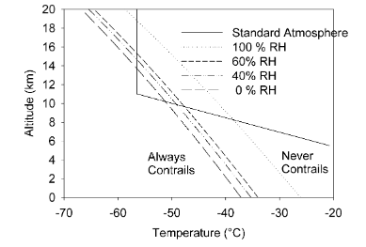

Figure 1 [1]

The life span of a contrail depends on the temperature and the relative humidity. Therefore, contrails have a long lifespan when the humidity of the air is larger than the saturation humidity over the ice surface [1]. In these super-ice-saturated regions, the contrails continue to grow by the ambient humidity in the surrounding area and will continue to grow if it stays ice saturated.

Ice Supersaturated regions (ISSRs) are a phenomenon in very cold regions of the atmosphere. Some of the properties of ISSRs are that they are cloud-free regions in the cold layers of the atmosphere below the supercooling limit of water but there is no clear border between cloud-free ISSR and ice supersaturation within cirrus clouds [2]. ISSRs can be identified through satellite instruments and figure 2 is a colorized diagram from satellite data showing the frequency of occurrence of ISSRs for different altitudes and they are mainly located just below the tropopause [2].

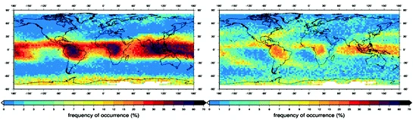

Figure 2 [2]

Contrails and their properties and locations are still being researched since they are not completely understood. One of the reasons behind that is that satellite tools cannot tell the difference between ISSRs and ice-supersaturated regions with clouds. What is known is that when aircraft fly through these regions they produce contrails, and they are a large component of climate change because of the aerospace industry.

Contrails are a serious factor in global climate change for the aerospace industry. Since contrails have similar characteristics to Cirrus clouds, they also are “transparent to incoming shortwave radiation from the Sun and redirect back to Earth the emitted outgoing longwave radiation” [3]. Figure 3 from Trenberth et al 2009 shows the results of contrails on short and longwave radiation.

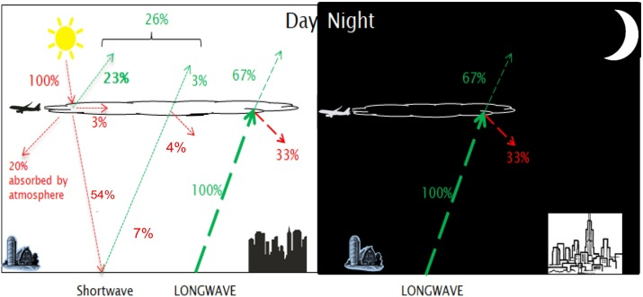

Figure 3 [3]

What this means for shortwave radiation is that 100% of the radiation comes down to Earth, 3% of the radiation is absorbed in the contrail and 23% is reflected before it can reach the Earth’s surface. In this model, the Earth’s albedo reflects 7% of the shortwave radiation. The contrail reflects 4% of the reflected radiation and allows 3% back through. This means that 26% of the shortwave radiation is returned to the atmosphere, which can result in climate cooling. The contrail's effects on longwave radiation are the same during the day and night. Since longwave radiation is the heat escaping the Earth, according to this example 33% of the escaping longwave radiation is reflected down to Earth which can result in climate heating. According to Avila, Sherry, and Thompson the result of the contrail's reflection “increases atmospheric greenhouse warming approximately a net of 10% during the day and 33% at night” [3].

The identification of contrails can be difficult since some aged contrails look like naturally occurring cirrus clouds. One distinction between the two is the linear shape of contrails. But there has been research using machine learning to identify contrails. One study used machine learning algorithms to identify contains in 100,000 satellite images. [4]. What this research discovered is that comparing the contrail coverage from 2019 to 2020 that there was a 22.3% reduction in contrail coverage because of the 35.8% reduction in distance flown by aircraft over the 8 km altitude because of the novel Coronavirus 19 [4].

## Problem Space

Aircraft engines release exhaust in the form of condensation trails called contrails that when combined with cold temperatures form ice clouds that are hazardous to the environment. These ice clouds are a product of an accumulation of exhaust from planes that fly at the same altitude. The ice clouds formed to look like cirrus clouds but are manmade and contribute to global warming by reflecting radiation coming in and out of earth causing heat to become trapped on the planet. While there are methods to target and eliminate contrails the problem arises in correctly differentiating the ice clouds from naturally formed ones. The current resources being used to identify contrails are in the form of applying machine learning networks and neural networks to satellite images to create contrail recognition systems. Current contrail recognition systems have provided a solid foundation to build upon, but there has not been a solution that has been completely maximized due to the limitations in place of satellite imaging. The images of satellites for the most part lack resolution especially when trying to a fine point for contrails. Accumulating enough data to recognize these ice clouds subsequently becomes problematic when considering that outside of highly humid regions some contrails don’t last enough to show up on satellite scans that capture the entire United States airspace every 15 minutes. There are already measures in place that address this issue, but there is still additional work that needs to be done such as continuing accumulate data on contrails and improving existing algorithms to enhance the accuracy of the contrail recognition systems.

The hope is that by being able to swiftly identify areas where contrails are accumulating that air traffic controllers will be able to divert planes upwards or downwards in altitude to avoid regions that are saturated with ice. It is estimated that with the proper efforts in place to alert planes to adjust their altitude that the effects of contrails on global warming can be decreased by as much as half with the potential for more [3]. Previous efforts by previous groups have set a strong precedent for the work that needs to be built upon as well as possible areas of remediation.

The challenges associated with the algorithms in place stem from using real-time data to provide accurate object detection. The path to doing so is implementing neural networks for images that provide probabilities for classes by approaching the problem through a regression scope. Bounding boxes are then implemented on images to recognize contrails. This is something that both the initial project of Google and the previous team strived for. The technique of segmentation is an advanced and rely heavily on data maturity and technical skill.

## Research

Google’s initial efforts on this front resulted in the “first large dataset of pixel-level contrails locations labeled by humans in Landsat-8” data [5].

The original dataset of this effort utilized human-labeled data. This is one limitation highlighted in the research: the lack of well-labeled datasets. The immediate previous efforts in this area leveraged automated tools to aid in labeling. Furthering the previous efforts, there was a need to investigate other platforms that can be used for labeling images and running models. After looking at Momentum Ai, Roboflow, Amazon SageMaker, and AutoML Vision Edge. AWS Sagemaker clearly stood out as an area that we could leverage current knowledge, but add to it as well.

Previous immediate efforts identified YOLO as deep-learning algorithm that provided good object detection results. YOLO works by using three different techniques: residual blocks, bounding box regression, and intersection over union (IOU) [6]. There have been several iterations of the algorithm: YOLOv3, YOLOv4, and most recently YOLOv5. YOLOv4 is an improvement on the YOLOv3 algorithm by having an “improvement in the mean average precision by as much as 10% and the number of frames per second by 12%” [7].

In order to identify a good object detection model. We surfaced different image classification algorithms that we can leverage with transfer learning: Only Look Once (YOLO), Single Shot Detector (SSD), Region-based Convolutional Neural Networks (R-CNN), Mask R-CNN.

## Solution Space

Using the previous team’s effort in which they strived to create a system to automatically download satellite images, detect contrails using object detection machine learning, and produce coordinates of highly concentrated areas containing contrails, we will expand the efforts by pivoting to a binary classification of the images to detect contrails. We will use the previous team’s dataset of images that contain contrails as our training set so that we can look at new images to identify more images that contain contrails. In parallel with the model and algorithm selection, effectively and efficiently expanding upon the labeled dataset, if feasible, may advance the evaluation and accuracy of the model and algorithms selected.

## Project Objectives

Our project objectives are both technically rich and meaningful to the world at large. The impact of contrails. As noted by McCloskey et al [5], contrails can be initially defined as “cirrus clouds caused by jet aircraft, which by trapping outgoing infrared radiation, are likely aviation's largest contribution to global warming.” From our initial meeting with the project sponsor, we were impressed by the willingness on a community basis to help identify the unique patterns in the sky of the most prevalent contrail regions, often forming unique shapes such as crisscross combinations. We hope to build on the efforts of the previous class in at least 3 principal ways. First, we will use binary classification to assess images with true positives, true negatives, false positives, and false negatives in identifying the presence of contrails. On success, we’ll advance to image segmentation. Second, to verify the richness of computer vision detection models beyond the initial dataset used, noting the active volunteer community seeking to address this problem. The third is to apply the algorithms and expanded data on additional platforms such as Amazon Sagemaker to confirm the portability and agility of the analytic framework to powerful and leading cloud platforms. The ultimate value will be to identify those areas where contrails are most prevalent, and effectively and efficiently with this information inform global flight operations to take effective mitigation actions.

## Primary User Stories

Below are the initial user stories to help the team guide to meet the objectives of the project.

As a developer, I want to implement a brand-new algorithm to provide contrails accuracy of better than 50%.

As an air traffic analyst, I should be able to differentiate the presence of contrails in satellite images to assist air traffic controllers to redirect flights.

As a government stakeholder, I want to identify regions of contrail prevalence, establish a fair playing field and consistent guidance for airlines to follow in terms of clearly defining regions to avoid.

## Product Vision

As an initial scenario, United Nations Environment Programme (UNEP) may find this of value as this group is the leading environmental authority in the United Nations system. UNEP is monitoring Ozone trends because numerous studies have suggested that aviation could potentially lead to significant chemical release and changes in the atmosphere, especially the Ozone layer. The chances of this causing climate change and leading the global warming are higher by the day. This product can aid UNEP to identify the approximate location of contrails and take appropriate action. In addition, we were impressed by the Contrails Avoidance Workshop conducted on September 7 (https://nari.arc.nasa.gov/ContrailAvoidanceWorkshop). Our team’s participation may lead to additional collaboration and knowledge-sharing opportunities as this work continues to mature.

The Contrails Avoidance Workshop also provided a powerful experience in understanding the role of contrail detection and avoidance in the airline travel ecosystem. Knowing the conditions and specific geographic regions where the impact of contrails may be most prevalent may help airlines to mitigate their impacts. As offered in a workshop panel discussion [will cite specific agenda or speaker if we have in notes], flight planning software can be adjusted to avoid contrail regions, but this requires lead time, and we perceive, a fair and unbiased basis upon which these regions are identified for fuller adoption. A fair playing field, based on collaborations with academia, industry, and government guidance or policies, may promote equity to ensure economic impacts of contrail avoidance balance mitigations in an equitable manner.

## Definition of Terms

**Shortwave radiation**: Shortwave radiation is radiation at wavelengths shorter than 4 microns. Sometimes it is called solar radiation. Usually, radiation in the visible and near-infrared wavelengths [8].

**Longwave radiation**: Longwave radiation is radiation with wavelengths longer than 4 micros. Also referred to as infrared radiation or terrestrial radiation [9].

**Cirrus clouds:** Cirrus clouds are the highest in elevation, which form above 20,000 feet. The temperature at that elevation is so cold that cirrus clouds are usually composed of ice crystals. The ice crystals are the result of the freezing of super-cooled water drops. This can only happen when the temperatures reach below –38 degrees Celsius. These high-level clouds are white, thin, feathery, and wispy in appearance. Cirrus clouds often mark the start of a warm front, which is an indication of approaching bad weather. They are the fastest moving in the atmosphere because the wind current is very strong and high up [10].

**Albedo:** Albedo is the ratio of the radiation (radiant energy or luminous energy) reflected by a surface to that incident on it. Snow and cloud surfaces have a high albedo because most of the energy of the visible solar spectrum is reflected. Vegetation and ocean surfaces have a low albedo because they absorb a large fraction of the energy. Clouds are the chief cause of variations in the Earth's albedo [11].

# Data Acquisition

## Overview

There are two datasets in use for our project both of which were provided by data from Landsat- 8 satellite images. The satellites surface earth using thermal and multispectral instruments to provide 30-meter resolutions every two weeks. Both datasets are publicly available through the Google Cloud Platform (GCP). The first of the two datasets is 18 GB and in JSON format. The dataset is composed of 4,200 image references that have been analyzed by Google researchers for the presence of contrails. Using an array of methods such as studying flight paths, waypoints, the Mannstein et al algorithm, and the Appleman-Schmidt criterion the researchers were able to determine the presence of contrails in 47% of images. Subsequently, the second dataset which was provided by the United States Geological Survey (USGS) is in GeoTIFF format and provides the source images listed by reference in the Google contrail baseline JSON files.

## Google’s Landsat Field Descriptions

Google has its own storage system for the USGS Landsat images in its cloud storge system. All the major information that we would want to know about the image can be found in the URL for the image. The following image is from XXX and shows the different metadata in the URL. What can be found is this image is that there are 11 different bands for each image. Each of these bands relate to different wave lengths.

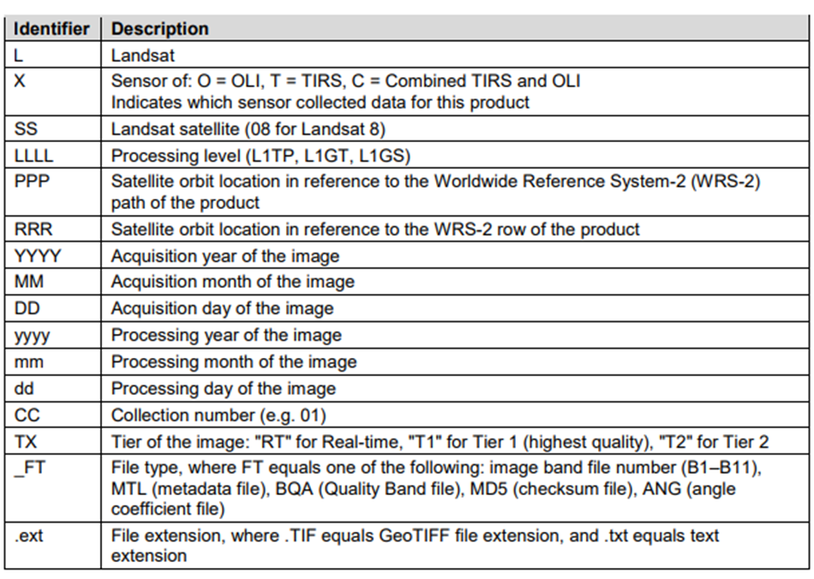

Figure 4

The image below is from the NASA Landsat Science website. This image shows the bands and which wavelength it is filtered at. According to the website, Band 1 is designed to measure chlorophyll concentrations in coastal regions, Band 9 is for detecting cirrus clouds and their shadows, and bands 10 and 11 are thermal infrared bands [12].

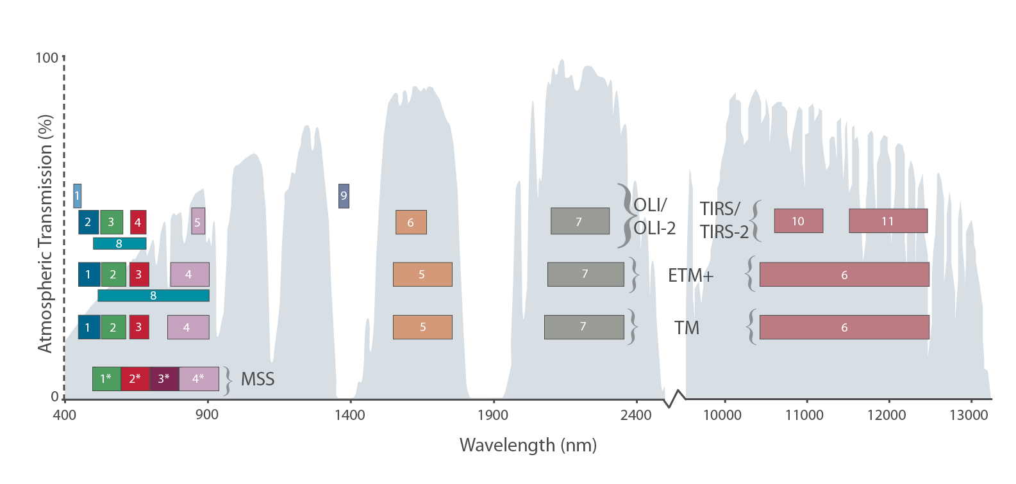

Figure 5 [12]

* **Publication Date (Type: DateTime)**: 2021/01/01
* **URL (Type: string)**:

<https://console.cloud.google.com/storage/browser/gcp-public-data-landsat/LC08/01/044/034/LC08_L1GT_044034_20130330_20170310_01_T2>

/SENSOR_ID/01/PATH/ROW/SCENE_ID/

The components of this path are:

* SENSOR_ID: An identifier for the particular satellite and camera sensor.
* 01: An indicator that the data is part of [Landsat Collection 1](https://www.usgs.gov/core-science-systems/nli/landsat/landsat-collection-1).
* PATH: The WRS path number.
* ROW: The WRS row number.
* SCENE_ID: The unique scene ID.

## Data Context

Landsat is a part of the USGS National Land Imaging (NLI) program and acquiring of Landsat images started in 1972 to help make informed decisions about the environment. It is spatial-resolution imagery that provides large areas of repeated data coverage at a scale that enables users to see detailed human-scale processes. This data archive contains images of detail allowing users like us to study different aspects of the planet and make informed decisions. The Landsat contrails dataset holds a baseline of contrails images as hosted by Google in the cloud environment. Landsat Collection 2 contains Level 1-4 data from Landsat 1-9 and will be used for the project.

Landsat Collection 2 is the second major reprocessing effort on the Landsat archive. This eventually resulted in data improvements because of data processing, algorithm development, and data access and distribution capabilities.



Figure 6

## Data Conditioning

Broadly, our team is focused on the positive outcome of this step to assess and implement highly efficient and scalable techniques to establish machine learning pipelines that can verify image detection models for contrails. After the successes in Sprint 1 to verify the capability of the Sagemaker environment to host kernels compatible with required libraries, we began to search for efficient access mechanisms.

As offered in Section 2.3, the Landsat Collection 2 is targeted as it may have advantages and potential updates which may promote efficiencies and advantages in model generation and training.

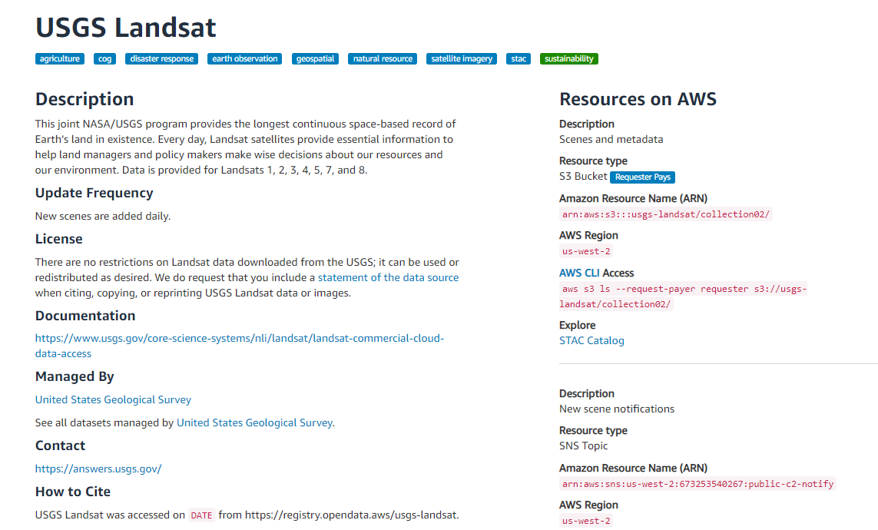

Figure 7 [13]

Of great benefit on this site are tutorials, including one which supports and guides developers through the intricacies of a Requester Pays AWS S3 bucket. The USGS resource “Landsat Cloud Direct Access Requester Pays Tutorial” link from the above page provides a Jupyter notebook-based example used to access images from the S3 bucket. Early in Sprint 2, we verified access within the Sagemaker Studio environment.

A powerful and continuing collaboration with the Summer Capstone group has helped us to understand that posted images are not all the same sizes. This was a challenge in previous efforts in the Summer to label data, as care will need to be taken to ensure that bounding boxes or other region identification techniques are positioned correctly. Being able to account for varying image sizes and potentially per-image annotations will need to be performed efficiently and consistently. A second insight is that while the RGB image resolution may be a reasonable choice for understandability of image identification, using filtered images based on specific wavelengths or color channels may increase the contrast which image detection models may need to identify the presence of contrail.

## Data Quality Assessment

There are two aspects of the data for this project: the Landsat images and the bounding boxes that identify contrails in some of the images. Each of these data sources is assessed below for data quality. The data is complete from the Landsat images. The bounding boxes JSON files are complete with all five coordinates, the four corners of the polygon, and the grounding point. Not all Landsat images have contrails so there are not an even number of images and coordinate files. There are no duplicates in the Landsat images. Some of the images do have the same land masses but they are from different days and times. Since the bounding box files are linked to a specific Landsat image by a unique file name string, these files are unique. Whenthe bounding boxes are placed over their corresponding Landsat image, the bounding box does not line up with the contrail. The accuracy of the boxes is very low. To correct this the images were shrunk down by a factor of 10 and the bounding boxes were more lined up with the image of the contrail. The data set does not have atomicity. Each of the bounding boxes needs to have the corresponding Landsat image to provide context and actual data besides a list of four numbers. Along with not having atomicity, the data sets do not have conformity. The Landsat images are of different sizes. They are all the same shape, a four-sided polygon, but the actual size of the polygons is different but around the same size. The overall quality of the data sets is very good. There are no known missing images or variables and there are no duplicate entries in the data set. There are some conformity issues, but this issue is not a large one because the bounding boxes are sized to the image.

## Other Data Sources

There was a set of annotated images created by the previous team. These annotations were marred, and the bounding boxes no longer aligned with the photos. If the team has the bandwidth, we will attempt to realign these bounding boxes to the images.

If time permits, the team could leverage GOES16 and GOES17 data [14]. Since this data is housed within AWS, the team could procure additional AWS services such as Amazon Sage Maker to build, train, and deploy a model by directly interfacing with the GOES S3 bucket.

# Analytics and Algorithms

## Hopper

The team leveraged the code from the Summer Team to get started on calculating the bounding boxes and was successful. Instead of using the YOLO algorithm to do contrail identification, we have decided to do a categorization of the images. The goal is to label images either “Yes” or “No” to contrails. There are a few steps that need to be completed before the identification can begin.

The first step is to convert the text files of the contrail polygon locations to JSON. Below screenshot shows our approach to converting files to JSON:

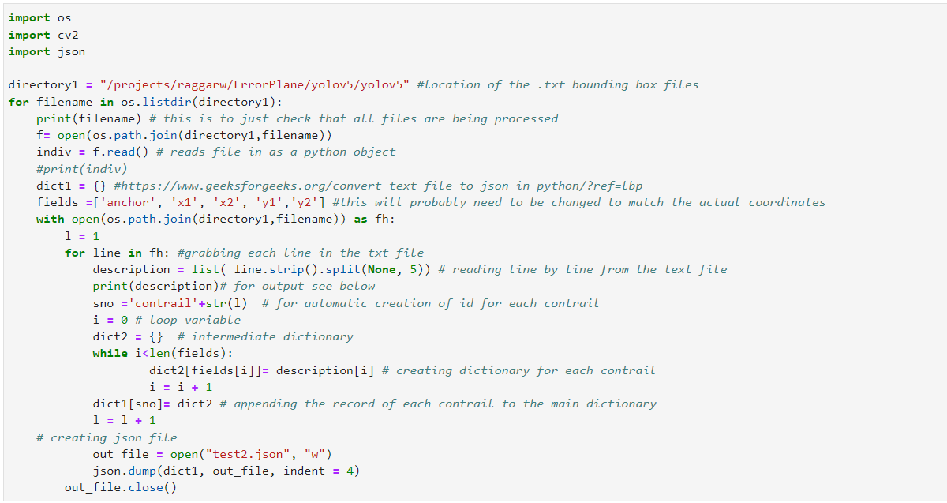

This was a necessary step since the chosen algorithm uses the bounding boxes in JSON format and the bounding boxes were saved as text files. After all the images and bounding boxes were saved in the shared Hopper environment, the next steps are separating the training and testing sets.

With assistance from George Mason University’s Office of Research Team, a shared environment was created where the images and bounding boxes' JSON files were stored. Here multiple folders were created to separate the training and testing images for the algorithms along with the bounding boxes. This was done by choosing the correct filtered image (train) and pulling in the testing data.

**High-level data processing pipeline for Binary classification on Hopper.**

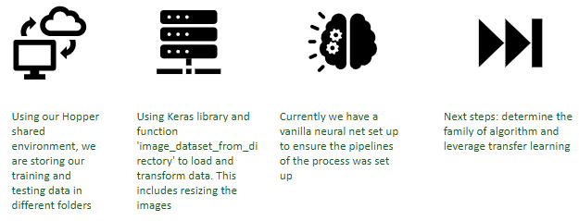

Figure 8

The Hopper Cluster is a batch computing resource available to all faculty and their students at George Mason University. JupyterLab is available as one of the interactive apps that can be launched directly from the Open OnDemand function of the Office of Research Computing. By having a familiar tool within the computing suite, our team was able to work jointly on this service. The Jupyter Notebook sessions are interactive and can be run for a maximum of 12 hours at a time. To run longer python jobs, you need to convert your code into a coherent python script that can then be submitted through SLURM.

Two Jupyter notebooks were created, one for importing data into Hopper and processing the image files to the correct format and the second for initial modeling purposes. Both notebooks can be seen on our GitHub repository.

Early issues prompted our team to make the effort to import the image files directly into a shared space on Hopper. Utilizing a shared single source of truth cuts down on potential confounding results and potential data leakage.

Environmental issues with Hopper arose when installing a major deep learning package, Keras. This has halted our team's progress until a solution can be found.

### Neural Network Structure

Utilizing Keras, we can leverage a function called `image_dataset_from_directory` to load and transform our data. Most of the preprocessing of the image sizes are done in this step. The structure of the directory directly impacts how Keras reads the data.

If your directory structure is:

*main_directory/*

*...class_a/*

*......a_image_1.jpg*

*......a_image_2.jpg*

*...class_b/*

*......b_image_1.jpg*

*......b_image_2.jpg*

then calling image_dataset_from_directory(main_directory, labels='inferred') will return a tf.data.Dataset that yields batches of images from the subdirectories class_a and class_b, together with labels 0 and 1 (0 corresponding to class_a and 1 corresponding to class_b).

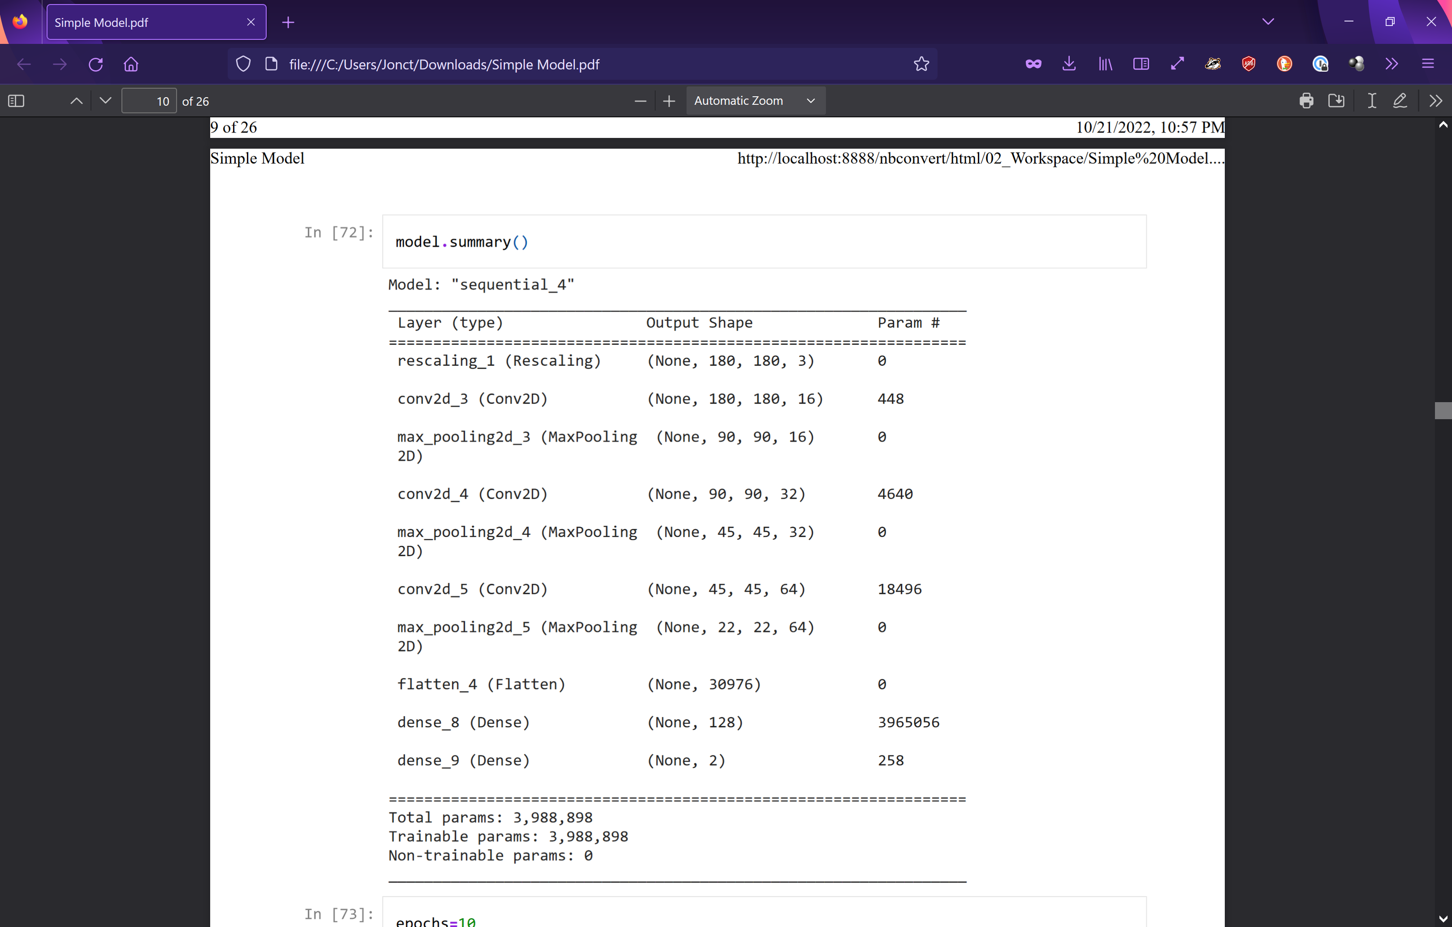We created a generic neural network for our first efforts. We wanted to ensure the pipelines of this process were set up. The following was the structure of our vanilla NN:

There were three max-pooling layers, three convolutional layers, and two dense layers. This was the initialization of this project, so all parameters are subject to training.

The initial end-to-end process leveraging the Keras package proved to be successful and stands as a jumping-off point to exploring different models.

### ResNet50

We performed initial testing utilizing a pre-trained algorithm, ResNet50V2. ResNet50V2 contains 192 total layers and weights. Transfer learning was leveraged when testing out the ResNet50V2algorithm. We froze the weights at 170 while leaving the last layers the ability to update. Doing so allowed our team to use the pre-trained model, leveraging the days of training, while being able to contextualize the model to our data.

The selection of which layers you allow to update based on individual data is arbitrary. Our team selected 170. Further exploration of which layers to freeze is an avenue to explore.

Model testing was performed using ResNet50 and ran to 10, 20, and 50 Epochs respectively. There was no material increase in accuracy when extending the epochs.

|  |  |  |
| --- | --- | --- |
| **Model** | **Number of epochs** | **Avg validation accuracy** |
| ResNet50 | 10 | 35.90% |
| ResNet50 | 20 | 35.90% |
| ResNet50 | 50 | 30.77% |

## SageMaker

Note that in this Section, summaries and diagrams are being derived from our team presentation slides, allowing us to elaborate on key themes.

Early in Sprint #3, we had an opportunity to expand the potential base of algorithm families and techniques we wished to explore. To verify end-to-end processing pipelines initial efforts sought to address the challenge of contrail identification through binary classification models, which provided several advantages listed as follows:

* Extension of analysis techniques and algorithm families beyond those associated with object detection
* Mitigation of subjectiveness from Contrail bounding box, based on the study of the Google training guide [15]
* Deference of some of the challenges experienced by the Summer Capstone team in aligning bounding boxes to source images of different sizes
  + Object detection precision in Summer Capstone using Roboflow was 7.3% average in the best performing model [16]
* Promotion of new lines of inquiry potentially well-suited for commercial cloud (Sagemaker) or Hopper capabilities
* Early verification with project sponsor with very positive feedback as potential being of value for repeatability and understanding for additional research teams

Within the Sagemaker environment, a high-level workflow can be offered as follows

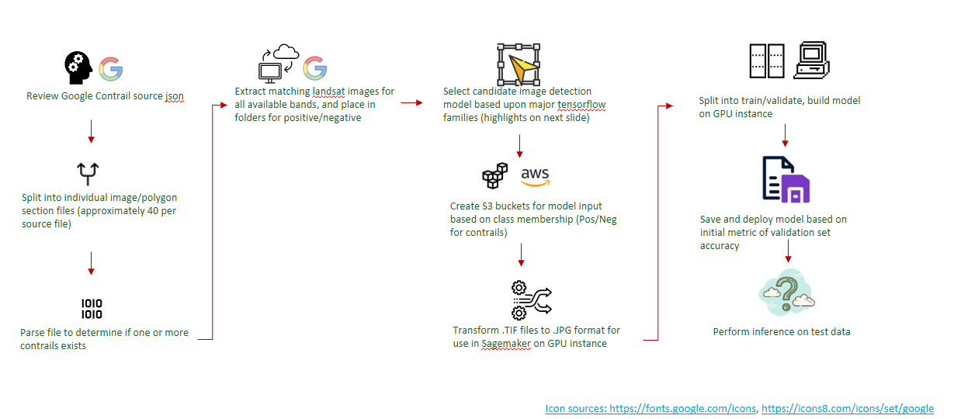

Of paramount importance will be to have clarity on the data used for generating models, as noted in the above illustration, to avoid subjectivity and error, we focused on using the data provided by Google, which has been the foundational and authoritative source of ground truth, as Google established the initial contrail label based. The original Contrail source JSON files are provided in a bucket with the following navigation structure.

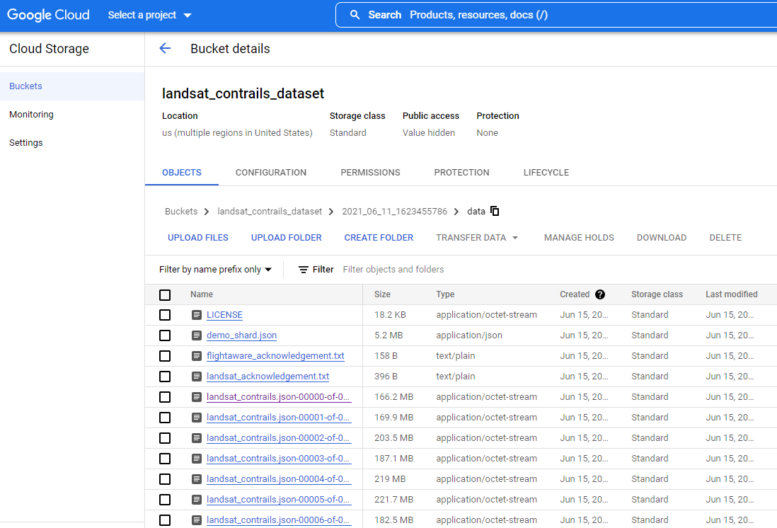

Figure 9

Reference: <https://console.cloud.google.com/storage/browser/landsat_contrails_dataset>

Within each JSON file, often listed as JSON 000nn-of-00100, there are embedded descriptions of approximately 30-40 specific analyzed images. As noted in the foundational Google paper [1], key fields within this file include: “the Landsat-8 filename, polygon bounds of contrails in the scene, and de-identified advected flight waypoints for each labeled Landsat-8 scene”. The Landsat-8 filename can be used as a prefix to access a second bucket, holding the specific images.

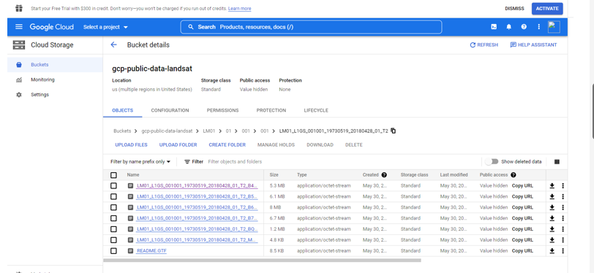

Figure 10

Reference: https://console.cloud.google.com/storage/browser/gcp-public-data-landsat

To further elaborate on the meaning of the links above, for any Landsat-8 filename, the Google-provided Landsat bucket provided multiple views of the image, initially created as artifacts to aid human labelers, but can provide rich and alternative training source collections. “The primary image was a false color image with the red channel being the brightness temperature difference between the 12 µm and 11 µm bands, the green channel being the 1.37 µm ”cirrus” reflectance band (omitted for nighttime images), and the blue channel is the 12 µm brightness temperature. In this false-color scheme, contrails appear as black linear clouds (see Figure 1). Two supplementary images were included: the true-color RGB, and an image representing advected flight density.” [1].

In processing and the remainder of the paper, the Google-provided sample code [reference below], highlights a shorthand file labeling notation we will leverage in our discussions, highlighting a mapping between specific color emphasis and wavelengths to file suffixes using a B3, B4…B11 notation.

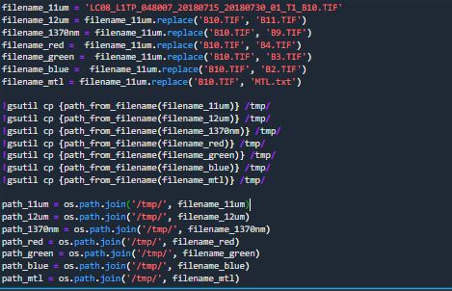

Figure 11

Reference: <https://storage.googleapis.com/landsat_contrails_dataset/2021_06_11_1623455786/code/landsat_contrails_dataset_code.zip> -> Landsat_Contrails_Dataset.ipynb

The initial analysis is promising, in initial verifications, JSON files 00001 and 00002 from the Google Landsat bucket were used, providing an initial set of 410 images across all bands, built from approximately 70 unique filenames. Initial performance using 4 distinct binary classifier families.

Table 1

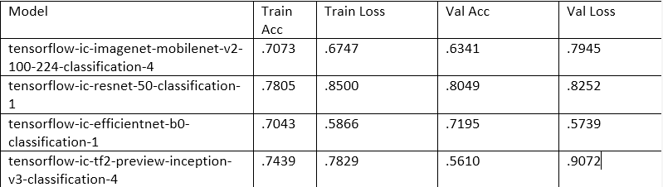

The first question we wanted to explore was whether the performance would improve with more training data. Indeed yes, the results show improvement when training with 2137 images (from JSON files 00003-00008 and 00010, as 00009 automated processing fails at the time of this writing) built from approximately 350 unique filenames. Note, models were trained and evaluated on the metric of validation accuracy, which for the larger training base improved significantly for the mobilenet and inception families while showing 1-2% variation for the resnet and efficientnet models.

Table 2

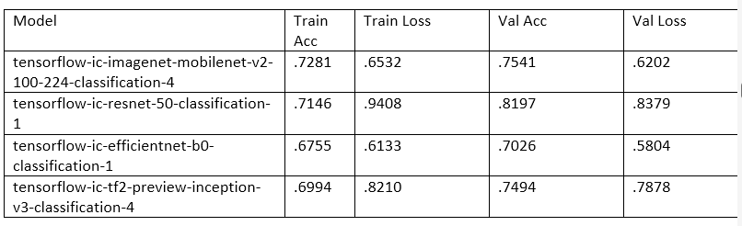

Next, the analysis focused on whether the technique to train on all available views for a given filename introduced significant overfitting. To explore this hypothesis, we are beginning the effort to perform analysis by image type. Again, the initial results are promising. Combining all available file images in the first 10 Google contrail bucket JSON aggregations (from file suffixes 00001-00010, noting a loading error for file 00009) at the time of this writing, and building models based upon the best performing resnet model above yields the following training performance metrics.

Table 3

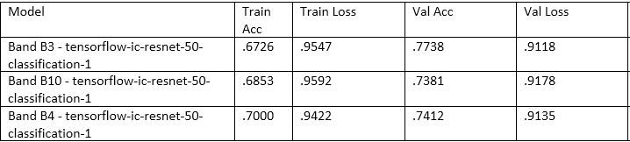

This helps to answer a key question from the summer work, are we likely to see differences in model performance if the analysis is focused on a specific type of available imagery. Initial answers seem to point to yes, based upon the table above, we see about a 4% difference in training accuracy based on the band selected. Further, this trend seems to transfer to unseen test data based on inference information captured within Sagemaker. Preliminary results indicate a better-than-chance accuracy for the B3 and B4 classifiers with unseen test data, while the B10 indicates a lower performance. We are excited that in Sprint 4 we may be able to show additional improvements by:

* Using training data in which positive contrail images contain instances of 4 or more contrails, which may capture existing phenomena such as crisscross contrails where the same airspace is accessed by multiple aircraft. The number 4 in this case is arbitrary to eliminate image captures of a smaller number of contrails
* Using the inference API to capture the confidence of the yes/no classification, indicating conditions when automated detection techniques work most effectively.

# Visualization

As we start Sprint 4, we are also emphasizing and iteratively refining our models from Sprint 3. One key aspect is being able to access and configure hyperparameters most relevant to model performance. Within Sagemaker, we are extending the analysis by band/resolution for a given model to see if expanding the number of epochs improves performance. Training and validation appear to have a strong impact.

Table 4

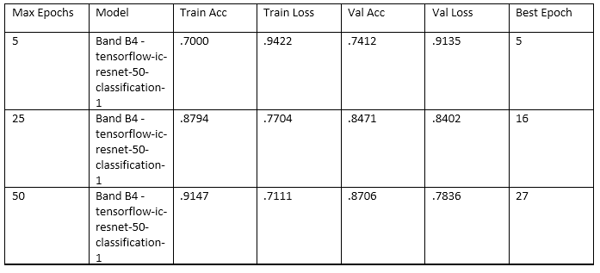

The table view as offered here may be a candidate to represent visually as part of continued experimentation. Note, it does not appear that these improvements readily transfer to our test data set within Sagemaker, but when implemented with fuller train/validation/test datasets we may see some of the results transfer to the previously unseen test data.

As we continue to make progress on our models, we have begun to explore visualizations that would best represent our data. There are four key ways we have envisioned best represent our results.

The first is a graph that illustrates how the outcomes of validation and accuracy from our models stack up against each other and the impact that can be derived from the number of epochs run. The aim is to have a measure of how the training data sets compare to our actual data sets. Additionally, these graphs will be able to portray which classifier families were most effective in identifying contrails. Below is a figure for our training and validation accuracy based on our best-performing resnet model in the Sagemaker environment for the B4 band using the Resnet-50 model. As depicted, towards the end training accuracy is significantly higher than validation accuracy. The inverse can be said for the results of loss when comparing the two whereas the epochs increase the loss is significantly lower for training. While the disparity between training and validation does increase, over time the results are still reassuring as the accuracy increases and loss decreases over epochs used for both curves. Moreover, the results from both visuals embody a model that is not underfitting.

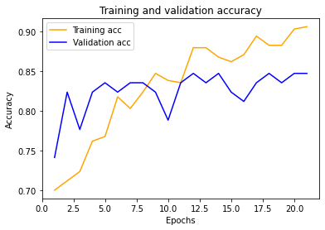

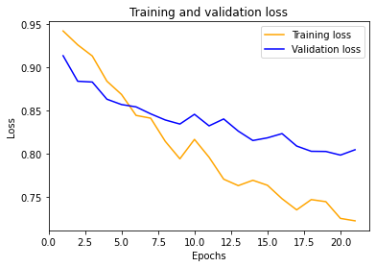

Figure 12

The second visualization will be a confusion matrix that illustrates how the bands used on different images performed in classification. The confusion matrix will allow for the ability to see how well each band was able to respond to our models and accurately predict the presence of contrails. True positives and true negatives will be the measure used by the graph and will portray the impact that image coloring has on the ability of the model to correctly locate and identify a contrail.

In the figures below we can see how different testing files and bands performed. The first two images are a composite of all bands for each file, images are then broken up for individual bands in subsequent images. As a whole file 00112 resulted in superior results compared to file 00111 especially when determining true positive contrail rates. Looking closer we can see that bands B3 and B4 ultimately were better predictors than the B10 band judging by the relatively higher rates of true positives and true negatives which are signs of more accurate outcomes. Again, the results for file 00112 proved to be promising regarding contrail classification.

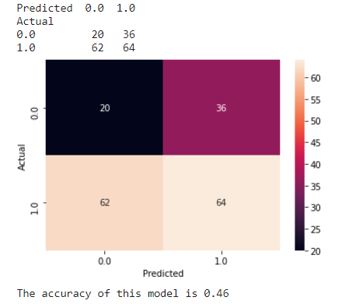

File 00111

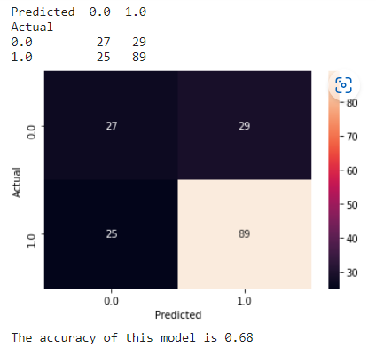

File 00112

**B3:**

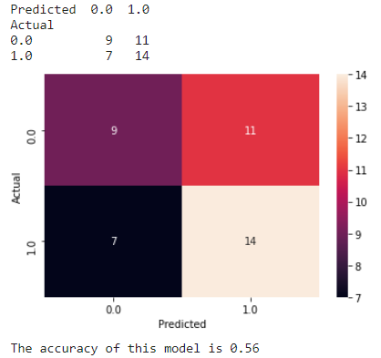

Figure for file 00111

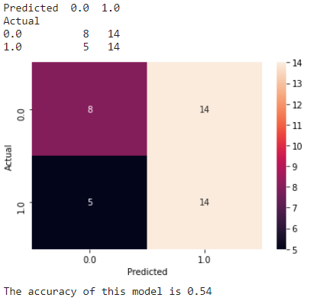

Figure for file 00112

**B4:**

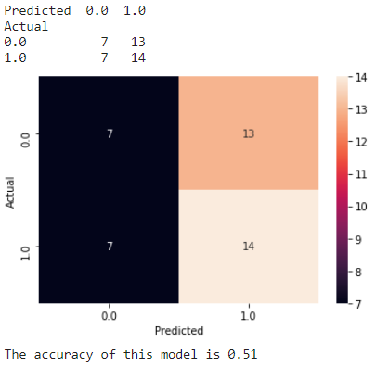

Figure for file 00111

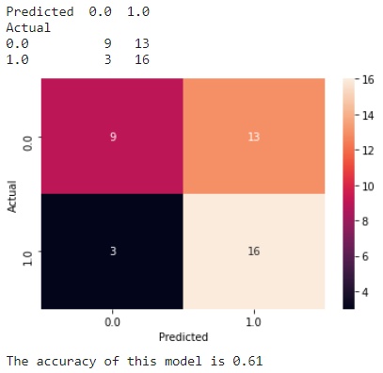

Figure for file 00112

**B10:**

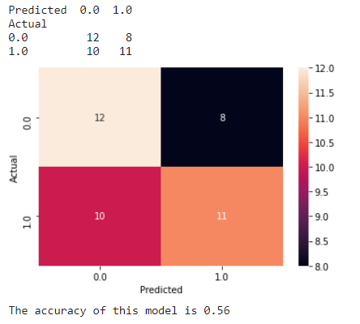

Figure for file 00111

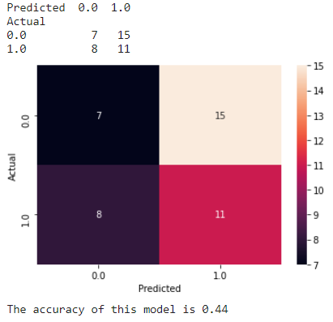

Figure for file 00112

Next, we have visualizations of the performance of our prediction model, pictured below is a graph produced that shows true positive and true negative rates on the blue line where true positive rates are equal to true negative rates on the dotted red line. This visualization serves to build confidence in the credibility of the predictions of the model. Sensitivity and specificity are important metrics to assess when working with ROC curves. Sensitivity is the ability of a model to correctly predict true values, while specificity is the converse and entails a model's ability to correctly predict true negatives. Again, we see that the 00112 files for the B4 red imagery band performed better judging by relatively higher true positive and true negative rates, in other words, we see better sensitivity and specificity. It is demonstrated on the curve by the blue line teetering along the top left of the graph and having an AUC of .66 which is the best among our models. The B4 file 00111 results on the other hand proved to be the worst performer, as exhibited by the low AUC value and the blue line mostly living below the red dotted line. The B10 band demonstrates volatile results between the two files tested. The 00012 files relatively provided better results in contrail identification with a higher AUC and having our blue line rise above the dotted line for most of the graph.

**B3:**

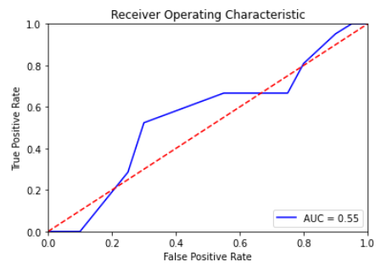

Figure for file 00111

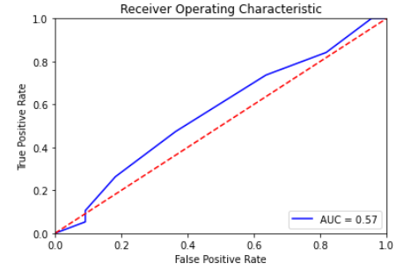

File for file 00112

**B4:**

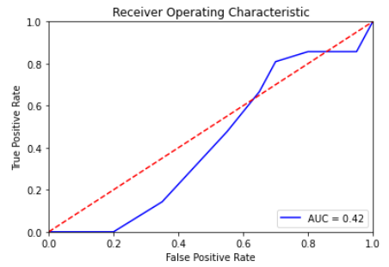

Figure for file 00111

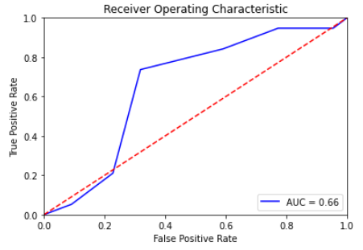

Figure for file 00112

**B10:**

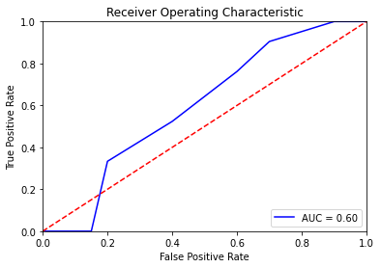

Figure for file 00111

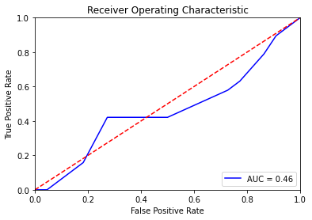

Figure for file 00112

Additionally, below are the training and validation accuracy and loss for the multiple runs of ResNet50 run in a local environment. These models were run on a CPU rather than GPU, so some of the oscillation could be resulting in memory dumping during training. Executing the modeling again leveraging the proper environment could result in differing results.

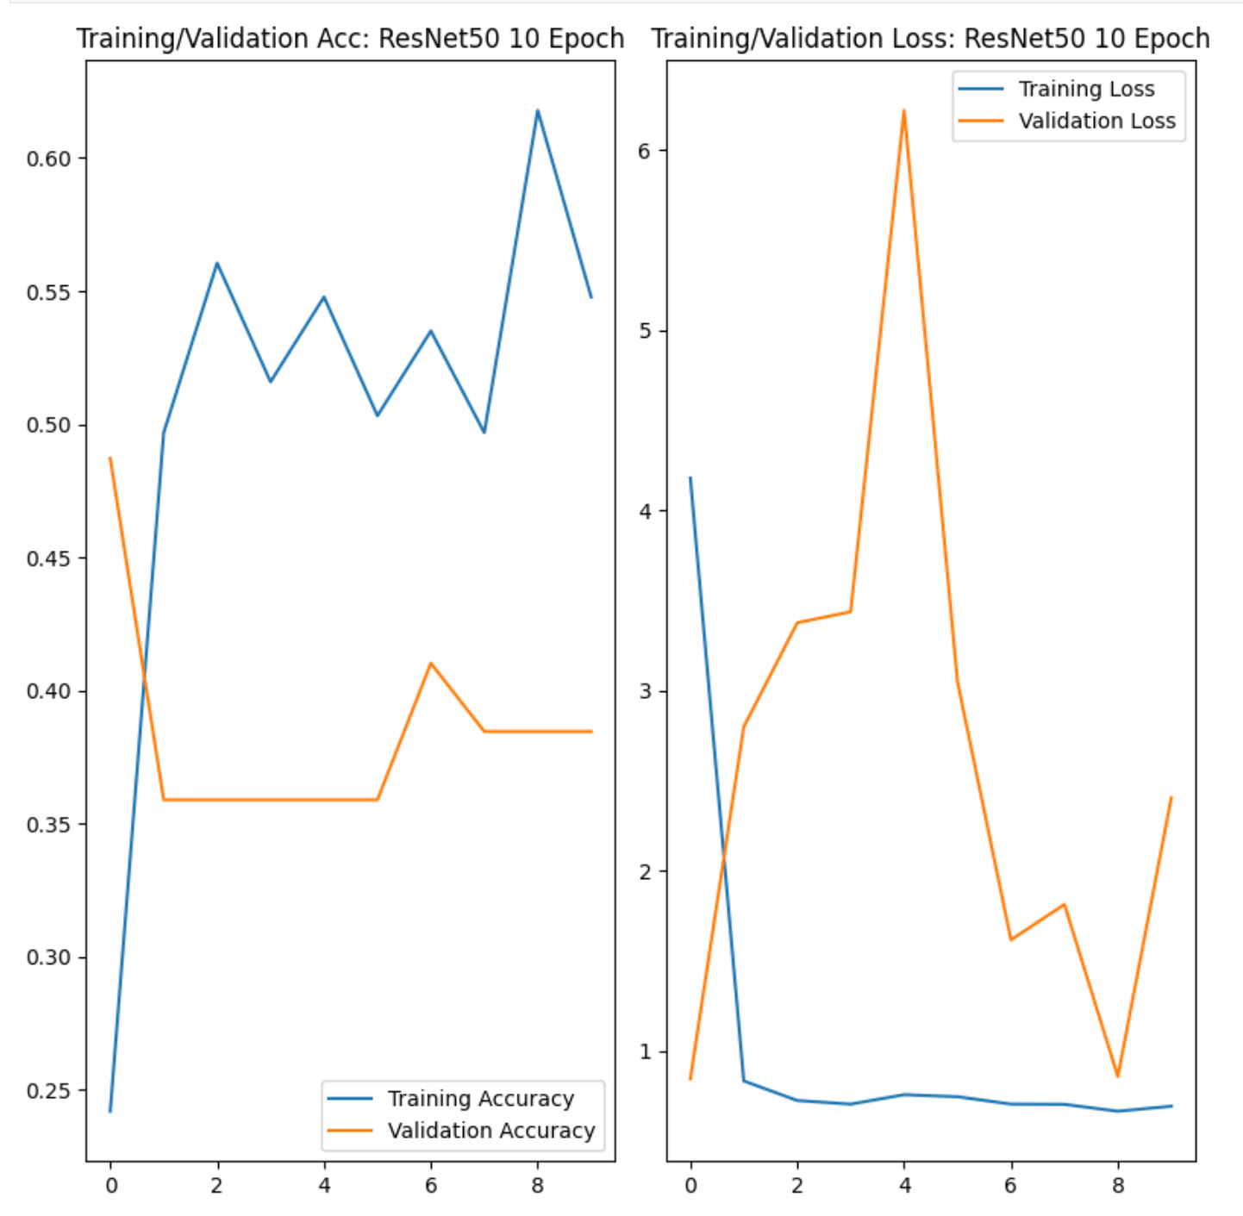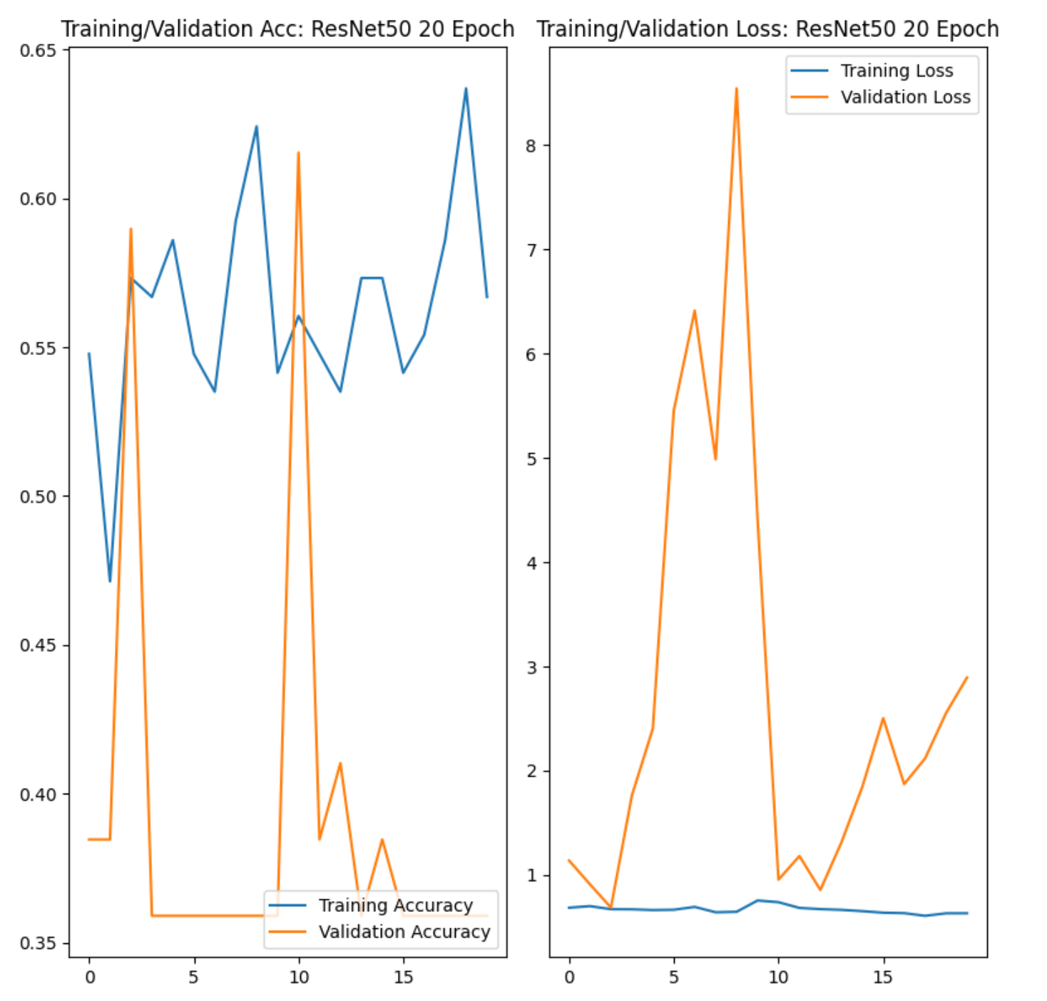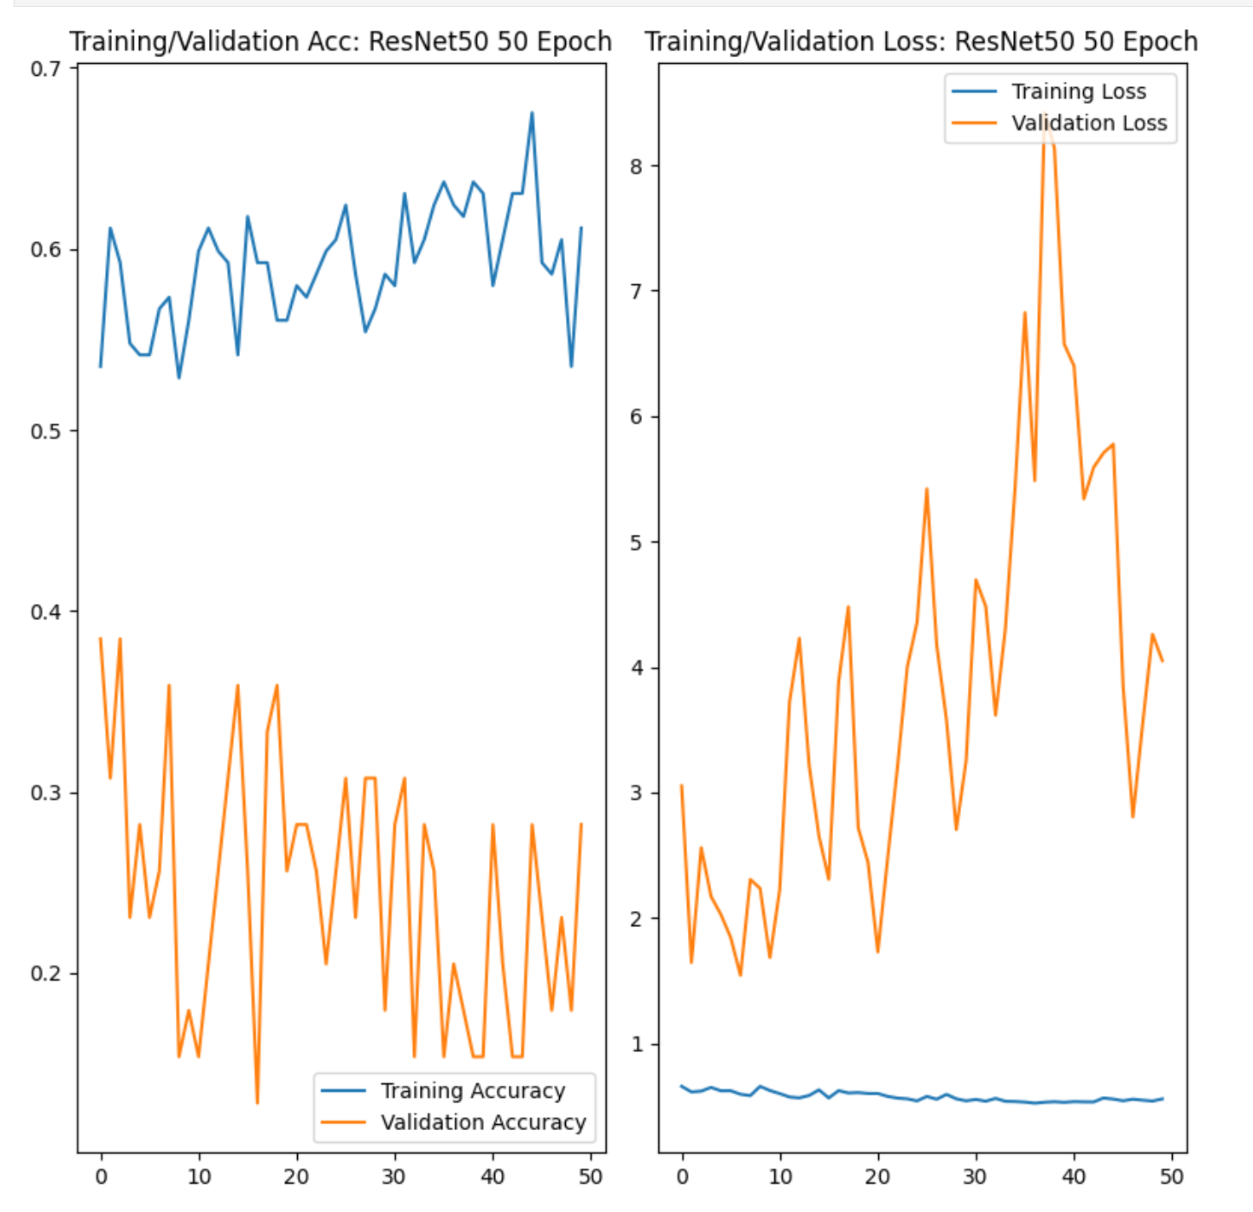

# Findings

We were privileged to be able to regularly meet with our project sponsor. Not only did this help us understand the domain and access additional learning and networking opportunities such as the Contrail Avoidance workshop as noted in Section 1, but it also provided opportunities to iteratively check in on progress and interim results. As we summarize our efforts here, it is useful to note the key results from the Sagemaker environment, as well as opportunities for continuing work.

During this capstone, we were able to demonstrate:

* Success on binary classification, with a measured performance improvement training with more data, seeing significant improvements when executing classification models with 410 images to a richer baseline of 2,137 images
* Comparison of multiple deep learning neural network families to see which one performs best on Contrail data from Google baseline set of annotated contrail image captures (resnet-50)
* Assessment of performance by the different types of imagery available (red channel, green channel, blue channel, and different wavelengths). Of the 3 types sampled, about a 4% difference in accuracy was noted. When run against test data, we saw predictions better than chance on the best performing bands, with 70%-80% validation accuracy across all bands, and 56% accuracy on previously unseen data in the best case.
* Modification of hyperparameters, and improved performance in training and verification accuracy, however, did not readily translate to improvements in previously unseen test data in initial testing.
* The inference capability works very quickly for the new image and provides confidence values as well as a result which may further help to refine and assess the performance

# Summary

To begin with, our team worked to expand the efforts started by the summer capstone team this past summer by pivoting to a binary classification of the images to detect contrails. Team Error-Plane worked to improve the accuracy and used two different environments: Sagemaker and Hopper.

The binary classification was a success! And the mode we chose utilizes binary classification to differentiate images into groups identified as having the presence of contrails or no contrails. We tested various models to produce the optimal accuracy and the most accurate model tested was the resnet model, this model produced an accuracy of about 77%.

The team went beyond and performed further analysis to determine if it is likely to see a difference based on the band or the resolution of the imagery used for training. The answer is yes – however, there is about a 4% difference in performance. And finally, we saw about 56% accuracy on previously unseen data in the best-performing band used for analysis.

Despite obstacles with Hopper and installing libraries, we were able to improve the accuracy of contrail detection and have compiled all the resources and materials for future teams in hopes that they can get started with ease.

# Future Work

The team has packaged efforts including Jupyter notebooks, which are available with Capstone delivery to enable further efforts, both in the Sagemaker and in Hopper. Future teams could take a look at detailed analysis leveraging the confidence interval scores to assess the strength of model detection, refining results and noting trends based upon the relative strength of the prediction. Additionally, verifying binary classification at scale on non-compressed images. The requirements of Sagemaker to use .png or .jpg files represented a transformation, in which the original .tif images were compressed. Such image transformation may introduce unintended error or data loss which can be confirmed through binary classification model execution image data not requiring transformation to another format.

Given our team had several roadblocks with Hopper, future work could also entail verification on the full image baseline, given the transformation required, our team sought to balance the depth of results with significant data while looking to use the Hopper environment to verify results on the full baseline. The Hopper verification remains a work in progress, but we hope to have left a foundation for other George Mason University research efforts to continue. And finally, the Sagemaker approach and code provided are compatible with object detection models, though more complex due to the annotations required, hence this effort could be expanded upon through selective refactoring, it may be possible to accelerate progress not only for the detection of contrails but localization within images as well.

# Appendix A: Code References

<https://github.com/Fall690-ErrorPlane>

## Team Error-Plane

This project uses computer vision machine learning to identify contrails in satellite images. Development and evaluation of these avoidance strategies greatly benefit from the ability to detect contrails on satellite imagery. Contrails condensation trails) are the ice clouds that trail behind aircraft as they fly through cold and moist regions of the atmosphere. Avoiding these regions could potentially be an inexpensive way to reduce over half of the aviation’s impact on global warming.

## Developers

1. Delaney Abigail Taubenberger
2. Jonathan Tyler
3. Lorenzo Rollhauser
4. Robert V Mikula
5. Pratibha Pandey

# Appendix B: Risk Section

## Sprint 1 Risks

Model understanding/biases – The utility of Shapley-based explanations may mitigate

|  |  |  |  |  |  |
| --- | --- | --- | --- | --- | --- |
| **ID** | **Risk Name** | **Description** | **Probability** | **Impact** | **Mitigation** |
| 1 | Computing Environments | Delays in access and initial deployments may compress schedules | Medium | Medium | Address in parallel both GMU cluster resources and commercial cloud offerings |
| 2 | Algorithm Selection | The choice of a new algorithm must provide value and inform future approaches, and the processing requirements for computer vision may limit the ability to test at scale | High | High | Tie directly to Sprint approach, fail fast for choices which are easier to implement but which may not be as accurate (OpenCV/Haar Cascade) |
| 3 | Dataset Access | The Google Landsat-8 image base may require additional expertise to access, deploy and render with the publicly available code base | High | Low | Study the open-source code processing guides from the Google bucket. Verify Landsat documentation to access Collection 2 on AWS |
| 4 | Cross-cloud compatibility | Given the leadership of Google, there may be optimizations favoring a Google-hosted GPU processing environment | Low | Low | Based on the initial code review, dependencies within the sample Jupyter notebook only seem to require base Python libraries. Many thanks to Kevin McCloskey of Google for their willingness to help with specific library installation issues (gdal). |

## Sprint 2 Risks

|  |  |  |  |  |  |
| --- | --- | --- | --- | --- | --- |
| **ID** | **Risk Name** | **Description** | **Probability** | **Impact** | **Mitigation** |
| 1 | Establishing a control set of images | We have labeled data. We need to figure out what constitutes non-contrail images | Low | High | Stakeholder questions and time visually inspecting the image |
| 2 | Dataset Access | The Google Landsat-8 image base may require additional expertise to access, deploy and render with the publicly available code base | High | Low | Study the open-source code processing guides from the Google bucket.  Verify Landsat documentation to access Collection 2 on AWS |
| 3 | Cloud resourcing in Sagemaker | Image classification tutorial models seem to require additional resources to run training, and outreach and resolution with AWS support have not been timely (~72 hours without resolution at the time of this risk input) | High | Medium | Start small and verify successful end-to-end execution on smaller batches or models while resourcing issues are being resolved for all required team members. |
| 4 | Image size variability | Images within the same collection appear to have different sizes. Normalization techniques or per-image annotation techniques will need to account for this in a scalable manner. | High | Medium | Tutorial resources within Sagemaker offer potential programmatic processing examples which may be generalizable to the Hopper environment once the images are labeled. Integration with labeling tools will be a focus in Sprint 3. |

## Sprint 3 Risks

|  |  |  |  |  |  |
| --- | --- | --- | --- | --- | --- |
| **ID** | **Risk Name** | **Description** | **Probability** | **Impact** | **Mitigation** |
| 1 | Lack of generalizability of models | Model performance may overfit to train/validation data and may not generalize to unseen test/data | High | High | Quantitatively compare models and bands to find the most promising subsets; train with all available images (thousands vs. hundreds) |
| 2 | AWS Sagemaker Platform update | Amazon Platform default changes for SageMaker Notebook Instances effective October 31 | Low | High | Verify if any prototypes to date impacted, study porting strategies |
| 3 | Opaque metrics | Metrics in Sagemaker were initially pulled from regex expressions of log files limited in utility | Low | Medium | Generate results based on inference with test data, verify AWS CloudWatch or Model Monitoring capabilities to see if run-time metrics possible at train time |
| 4 | Processing time even with GPU high | Image conversion and Model creation with GPU still require lengthy processing times | High | Low | End-to-end verification of the process indicates the ability to work stages in parallel, model training with 2000 images ~20 minutes which is manageable |
| 5 | Unbalanced distributions | Negative and positive distribution buckets are not equivalent | Medium | Low | A 40/60 split should be manageable, sampling techniques could be integrated |

## Sprint 4 Risks

|  |  |  |  |  |  |
| --- | --- | --- | --- | --- | --- |
| **ID** | **Risk Name** | **Description** | **Probability** | **Impact** | **Mitigation** |
| 1 | Library installations on Hopper | Team members focused on Hopper still working through environmental issues as of November 28 | High | Medium | Sagemaker results may focus efforts of remaining team members for local execution as required |
| 2 | Run longer epochs | Need to run longer epochs for the benefit of improved accuracy and visualizations | Low | Medium | Continue to run for longer epochs and then update visualizations as needed |

## Sprint 5 Risks

|  |  |  |  |  |  |
| --- | --- | --- | --- | --- | --- |
| **ID** | **Risk Name** | **Description** | **Probability** | **Impact** | **Mitigation** |
| 1 | Presentation Preparedness | Team member feeling unease about what topics to be covered during their portion of the group presentation | Low | High | Making use of class time to run through the presentation fully |
| 2 |  |  |  |  |  |

# Appendix C: Agile Development

## Scrum Methodology

The team met twice every week to provide updates on progress and to allocate tasks. The scrum methodology was easy to follow, and it has been helpful to make iterative and incremental progress. YouTrack is helping us stay on track regarding what tasks to focus on each week.

## Sprint 1 Analysis

Initially, it took a few days for team members to get access and situated in the system. And once we all were in the system, the process of creating user stories, assigning user stories to team members, and finally creating additional sprints (2-5) was simple and easy. The scrum master updates the user stories and assigns them to team members. The process so far has been working for our team.

We had three to four touchpoints during our first weeks of the Sprint. One during the scheduled class time, one during the Stakeholder engagement, and two others bookending our scheduled class. This engagement rhythm has proved useful to our team. We can review anything that needs to be submitted before class. As well, we are creating a list of action items after every class.

We have not been adhering to the daily standups. This is proved difficult to do since our entire team has full-time jobs outside of this program. However, the 4-day week tempo, complemented by group texts for quick turnaround matters, is providing timely collaborations.

## Sprint 2 Analysis

The focus for Sprint 2 was to acquire the dataset and start thinking of the algorithm that can be applied to the dataset. The team met with sponsors to provide updates and ask clarifying questions about the objective, technicalities, and overall project plan. Additionally, the team also met with the Summer Capstone Team to learn about the project, lessons learned and inquire about their algorithm.

The team had working sessions to help each other get to speed and help with environment set-up to start coding. Overall, it was a productive Sprint with lots of moving pieces and team members working hard to acquire the dataset and prepare for the next sprint, Analytics & Algorithm.

A focus in Sprint 2 was to ensure that all team members had access and baseline capabilities to execute Contrail detection within either the AWS Sagemaker or Hopper environments. In some cases, individual environments had issues that delayed progress, and in turn, contributed to challenges in fully participating in discussions. Team breakouts and virtual collaborations are working to overcome these challenges, and in the last week of the Sprint, we saw a growth in positive activity and momentum from all team members focusing on code execution and validation laying a foundation for Sprint 3.

## Sprint 3 Analysis

The length of time required to establish initial workflows in Sagemaker, and Hopper was and is considerable. Within Sagemaker, the workflow graphic in Section 3 benefitted from GPU capabilities for image preprocessing and model generation. While cloud features within AWS permit speed improvements when leveraging additional services such as S3 buckets for storage, initially metric generation may be opaquer.

Sprint 4 focus and visualizations may leverage open-source processing of the previously unseen test data used in inferences, where access to each test image classification and confidence is more readily available. The techniques and workflows used for binary classification algorithms as well, but the difficulties experienced by the team in the Hopper environment may make an initial focus on replicating or enhancing classification results early in Sprint 4 a critical focus.

## Sprint 4 Analysis

While we are continuing to test models in AWS Sagemaker and Hopper environments, we have also started exploring various visualization ideas to portray performance results.

Below is the list of initial visualizations the team will explore:

* Training and validation plot
* Confusion matrices for individual bands
* A linear graph that depicts how the amount of data influences the accuracy
* An AUC (area under the curve) plot for the performance of the model

The focus for this sprint is going to be both on ensuring our models are providing expected outputs and that the above-listed visuals are the optimal ways to showcase the models' performance.

## Sprint 5 Analysis

The team is going to focus on finalizing the project presentation and project report to prepare for the final showcase. Additionally, we will work to finalize our models and package resources, codes, and other supporting materials and upload them to the GitHub repository. This will help the future capstone teams to continue our efforts with ease.

# References

|  |  |
| --- | --- |
| [1] | U. Schumann, "Formation, properties and climatic effects of contrails," *Comptes Rendus Physique,* vol. 6, no. 4-5, pp. 549-565, May-June 2005. |
| [2] | K. Gierens, P. Spichtinger and U. Schumann, "Ice Supersaturation," in *Atmospheric Physics*, Berlin, Heidelberg: Springer, 2012, pp. 135-150. |
| [3] | D. Avila, L. Sherry and T. Thompsom, "Reducing global warming by airline contrail avoidance: A case study of annual benefits for the contiguous United States," *Transportation Research Interdisciplinary Perspectives,* vol. 2, p. 100033, 2019. |
| [4] | V. R. Meijer, L. Kulik, S. D. Eastham, F. Allroggen, R. L. Speth, S. Karaman and S. . R. H. Barrett, "Contrail coverage over the United States before and during the COVID-19 pandemic," *Enviromental Research Letters,* vol. 17, no. 3, 2022. |
| [5] | Kevin McCloskey, "A human-labeled Landsat-8 contrails dataset," Google, 2021. |
| [6] | G. Karimi, "Introduction to YOLO Algorithm for Object Detection," EngEd, 15 04 2021. [Online]. Available: https://www.section.io/engineering-education/introduction-to-yolo-algorithm-for-object-detection/. [Accessed 09 2022]. |
| [7] | H. Ampadu, "Yolov3 and Yolov4 in Object Detection," AI Pool, 04 05 2021. [Online]. Available: https://ai-pool.com/a/s/yolov3-and-yolov4-in-object-detection. [Accessed 09 2022]. |
| [8] | NASA, "Shortwave Radiation," NASA Earth Data, [Online]. Available: https://www.earthdata.nasa.gov/topics/atmosphere/atmospheric-radiation/shortwave-radiation. [Accessed 09 2022]. |
| [9] | NASA, "Longwave Radiation," NASA Earth Data, [Online]. Available: https://www.earthdata.nasa.gov/topics/atmosphere/atmospheric-radiation/longwave-radiation. [Accessed 09 2022]. |
| [10] | NASA, "Cirrus Cloud Systems," NASA Earth Data, [Online]. Available: https://www.earthdata.nasa.gov/topics/atmosphere/clouds/tropospheric-high-level-clouds-observed-analyzed/cirrus-systems/cirrus-0. [Accessed 09 2022]. |
| [11] | NASA, "Albedo," NASA Earth Data, [Online]. Available: https://www.earthdata.nasa.gov/topics/atmosphere/atmospheric-radiation/albedo. [Accessed 09 2022]. |
| [12] | NASA Landsat Science, "Landsat 9 Bands," NASA , [Online]. Available: https://landsat.gsfc.nasa.gov/satellites/landsat-9/landsat-9-bands/. [Accessed 28 11 2022]. |
| [13] | Registry of Open Data on AWS, "USGS Landsat," [Online]. Available: https://registry.opendata.aws/usgs-landsat/. [Accessed 2022]. |
| [14] | Registry of Open Data on AWS, "NOAA Geostationary Operational Environmental Satellites (GOES) 16, 17 & 18," [Online]. Available: https://registry.opendata.aws/noaa-goes/. [Accessed 2022]. |
| [15] | "Contrail Segmentation Policy," [Online]. Available: https://storage.googleapis.com/landsat_contrails_dataset/2021_06_11_1623455786/docs/Contrail_Labeler_Instructions.pdf. [Accessed 25 11 2022]. |
| [16] | L. Colelli and et al, *Image Processing Satellite Images for Contrails,* Fairfax: George Mason University DAEN Final Report, 2022. |
| [17] | G. Karimi, "Introduction to YOLO Algorithm for Object Detection," April 2021. [Online]. Available: https://www.section.io/engineering-education/introduction-to-yolo-algorithm-for-object-detection. |
| [18] | H. Ampadu, "Yolov3 and Yolov4 in Object Detection," ai-pool, May 2021. [Online]. Available: https://ai-pool.com/a/s/yolov3-and-yolov4-in-object-detection. |
| [19] | [Online]. Available: http://www.theozonehole.org/airtraffic.htm. |

Note, the team will confirm access to, consistency, and compatibility with the Microsoft Word reference capabilities, and will use this section to assemble the in-line references noted to date.

[12] Simmon, Robert. “A Gentle Introduction to GDAL Part 4: Working with Satellite Data.” *Medium*, Planet Stories, 21 May 2018, <https://medium.com/planet-stories/a-gentle-introduction-to-gdal-part-4-working-with-satellite-data-d3835b5e2971>.

[13] Engdahl, Sylvia. “Identify Rooftop Solar Panels from Satellite Imagery Using Amazon Rekognition Custom Labels.” *Amazon*, Greenhaven Press/Gale, 2008, <https://aws.amazon.com/blogs/machine-learning/identify-rooftop-solar-panels-from-satellite-imagery-using-amazon-rekognition-custom-labels/>.

[14] Mitr, Giannis. “Amazon-Sagemaker-Examples/amazon_jumpstart_object_detection.ipynb at Main · AWS/Amazon-Sagemaker-Examples.” *GitHub*, <https://github.com/aws/amazon-sagemaker-examples/blob/main/introduction_to_amazon_algorithms/jumpstart_object_detection/Amazon_JumpStart_Object_Detection.ipynb>.

.